ZEN NIPPON AIRINKAI  SOUTHERN CALIFORNIA CHAPTER  50th ANNUAL ZNA SOCAL KOI SHOW  & ZNA AMERICA WESTERN DISTRICT SHOW | 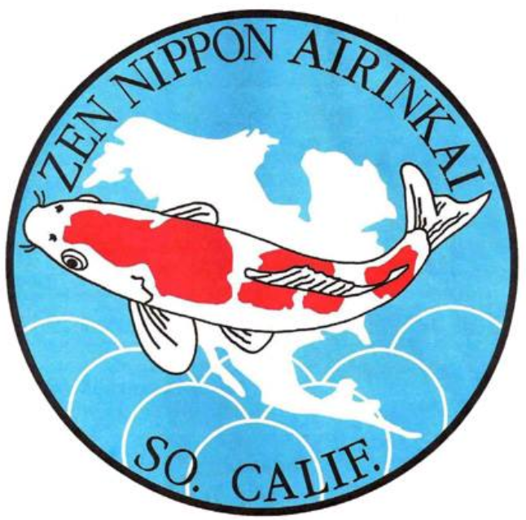
Dear Vendors and Sponsors,
The 50th Annual ZNA Southern California Chapter Open Koi Show, co-sponsored by the City of Gardena Department of Parks and Recreation, will be held March 20–22, 2026, at the Gardena Civic Center Complex (1700 West 162nd Street, Gardena, CA 90247).
This milestone event will also serve as the ZNA America Western District Show, bringing increased visibility, attendance, and industry participation. As the longest-running koi show outside of Japan, this event offers a unique opportunity for vendors to showcase products and services to a highly engaged audience of koi enthusiasts, hobbyists, and industry leaders.
Thank you in advance for your generous support of our koi club. Trophy sponsorship and booth reservations are on a first come basis, so please get back to us soon. Please call or email one of us with any questions you may have, we look forward to hearing from you soon.

Igal Yazdi Gerald Ellison Jane Morrison
President, ZNA SoCal Show Chair Vendor Chair
818-439-1921 858-888-9924 949-903-1856 igalyazdi@gmail.com ZNASOCAL@Outlook.com janemm27@gmail.com

With our show being the ZNA America Western District show this year, ZNA SoCal will be hosting President’s meeting and also host an accredited koi seminar. We are looking for a wet vendor as a sponsor and provide koi to be judged for the seminar. (Optional up to $1,000 bid or sponsorship)

Wet Vendor Registrations: (Limited Availability)
For Wet vendor registrations only, we only allow up to 5 wet vendors for our show. This will either be 3+2 (3 in region of SoCal and 2 out of SoCal) or 4+1 (4 in SoCal and 1 out of SoCal). Along with a wet vendor’s registration, other optional factors will be considered in selection of wet vendors. These may include any of the following:
- Any Show Sponsorship (Platinum, Gold, Silver, or other)
- Trophy sponsorship
- Show ring logistical support (Benching, wrangling, etc…)
- PR, marketing, social media
- Other contributions that support successful show operations
The first-round deadline for wet vendor applications and bids is February 29. After this date, applications will be considered based on remaining availability.

For all vendors, we have the following Show sponsorship available this year:
- 1 x Platinum Show Sponsorship ($3,500)
  - Trophy sponsorship of GCA and Reserve Champion A
  - Pop up banner or banners during Sunday award ceremony
  - Any social media, website, and presentation co marketing
  - Includes 1 booth registration and 1 tank if wet vendor
- 1 x Gold Show Sponsorship ($2,500)
  - Trophy sponsorship of GCB and Reserve Champion B
  - Any social media, website, and presentation co marketing
  - Includes 1 booth registration and 1 tank if wet vendor
- 3 x Silver Show Sponsorship ($1,000 per)
  - Sponsorship of Security services
  - Sponsorship of Hospitality and Entertainment
  - Sponsorship of Pond equipment, Pond building, and servicing
- 1 x “Kois of a Scale” Social hour Sponsorship ($1,000)
  - Saturday night social hour
Please contact Gerald Ellison for more information or any questions.

Additional 2026 Notes for this year’s show:
- There will be no show banquet this year on Saturday. Instead, there will be social hour Saturday night. More information to come.
- Judging results will remain confidential until the Sunday morning awards ceremony.
- This year’s show will end at 12pm Noon Sunday. Entrants and vendors can start to tear down at noon.
- All venders registration for our show must be in good standing in the koi community
- Any vendors requesting presence at our show by booth or table or any type of setup must register and must be approved before participating. This includes registration costs, table, and tent.
- All decisions by ZNA SoCal are final.
ZEN NIPPON AIRINKAI
SOUTHERN CALIFORNIA CHAPTER
50th ANNUAL ZNA SOCAL KOI SHOW
& ZNA AMERICA WESTERN DISTRICT SHOW

Show Vendor Reservation
(email below vendor form to Jane Morrison janemm27@gmail.com AND Gerald Ellison znasocal@outlook.com)

Process this year to register:
- Fill out this form
- Send this form and all additional information by email to janemm27@gmail.com AND ZNASOCAL@OUTLOOK.COM
- We will acknowledge receipt of your registration by email and/or phone
- We will email online invoice for you to pay from Square
  - Options to pay (Credit Card, Debit cards, Mobile wallets, ACH Payments

Name of Business or Activity: ______________________________________________________________
Contact Name (if not you): _______________________________ Contact Phone No: ________________
Email: ______________________________ Website: ____________________________________
Social media information (list and provide links): _______________________________________________
Description of Goods for Sale: ______________________________________________________________
_______________________________________________________________________________________
*please feel free to provide separate 1 page paragraph about your company history, missions statement, or any relevant info where we can market and share in our PR and marketing activities. If company has any marketing collateral and/or logos, please send via email

- If you sell items subject to sales tax, you are required to hold a valid CA Sellers Permit
- All vendors are required to stay till end of our show on Sunday, any exceptions or early departures must be requested 2 weeks in advance prior to the start of the show and must be approved by Show Chair.

Number of Spaces Requested: _________ X ($350 per ten-foot space) = ____________
Number of Show Tanks Requested: _________ X ($125 per six-foot tank) = ____________
You will need to supply your own air pump(s), nets, and extension cord(s). You will need to supply your own Oxygen tank if you’re a wet dealer.

Special Requirements/Requests: ________________________________________________________
___________________________________________________________________________________
Please contact me about Show sponsorship: (Circle one) Yes / No
Scheduled Set-up Date & Time: Fri. 3/20/26 or Sat. 3/8/26 before 9 am
Your estimate desire arrival Est. Date and Time: _____________
Wet vendors please note that we encourage you to set up Friday as many of our participants like to purchase koi Friday afternoon for entry in the show! Vendor booths, including reserved treated 6’ tanks will be set up and ready for you by no later than 1:00 pm on Friday March 20th. If there is any variance, we will notify you as soon as possible.
Show Site: Gardena Civic Center Complex
1700 West 162nd Street
Gardena, CA 90247
Either the Show Chairs or Vendor Chair will reach out and review your requirements and your setup prior to start of the show.
All payments will be required to be paid prior to Feb 29th, 2026 at the latest for any 1st round reservations. Earlier payment will guarantee reservations. ZNA SoCal is 100% cashless. Checks are not accepted. All balance must be paid by credit card or online invoice through Square.

Printed Name: _____________________________

Signature: ________________________________ Date:_____________________

